Smallwood C of E Primary Academy
Code of Conduct
Our Torch Logo reminds us that we are all lights shining in the darkness.
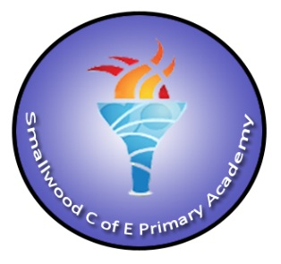
Make sure that you are showing the way.

- Always be kind and polite to everyone.

- Always respect others, our school and our environment.

- Make good choices for our school and keep our community safe and strong.

- Be considerate to others as you move around school.

- Be truthful and honest all of the time.

- Be a friend to the World.

- Look smart, think smart, be smart.

- Challenge yourself, be resilient, be independent and do it the Smallwood way.

