SMALLWOOD PRIMARY ACADEMY- AUTUMN TERM 2025-2026 CURRICULUM OVERVIEW
 | EYFS |  | YEAR 1 |  | YEAR 2
 | AUTUMN 1 | AUTUMN 2 | AUTUMN 1 | AUTUMN 2 | AUTUMN 1 | AUTUMN 2
Topic Name | Friendship & Animals | Celebrations | Changes within living memory. | From Asia to Australia! | The landscapes that form our world. | From Queen E to Queen V!
Humanities | Understanding the world- History  Begin to make sense of their own life story and family’s history | Understanding the world- Geography  People, culture and communities | History- changes to toys, book, games and food within living memory | Geography- locating the seven continents and exploring their human and physical features | Geography- Comparing and contrasting villages, towns and cities and their human/ physical features | History- Comparing and contrasting Queen Elizabeth I and Queen Victoria and developments in Britain during their reign
English (quality text) | The Something  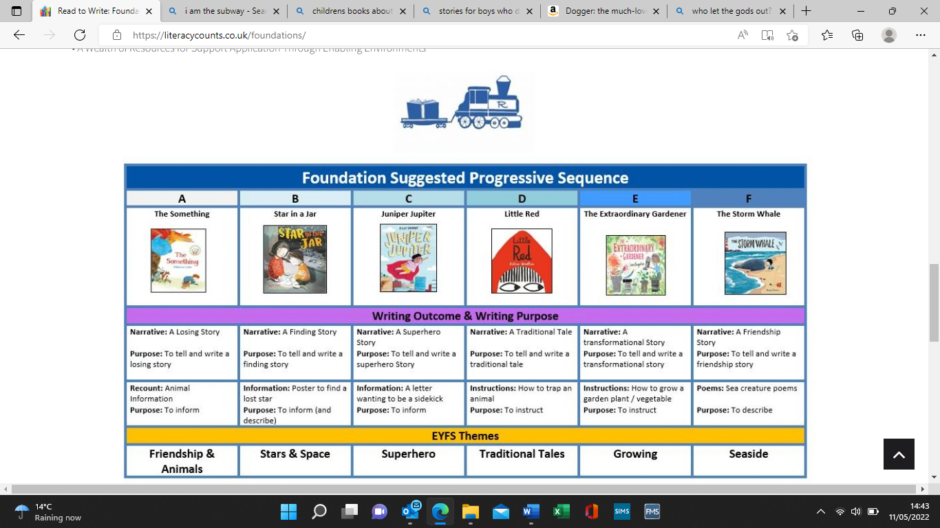 | Little Glow  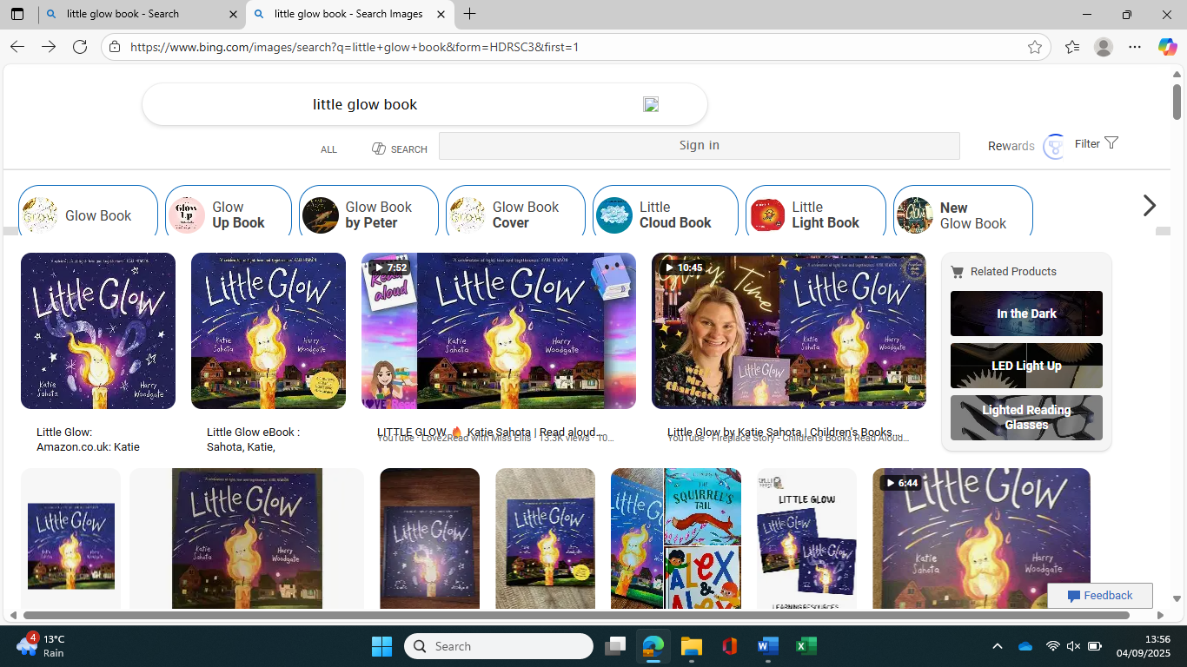 | 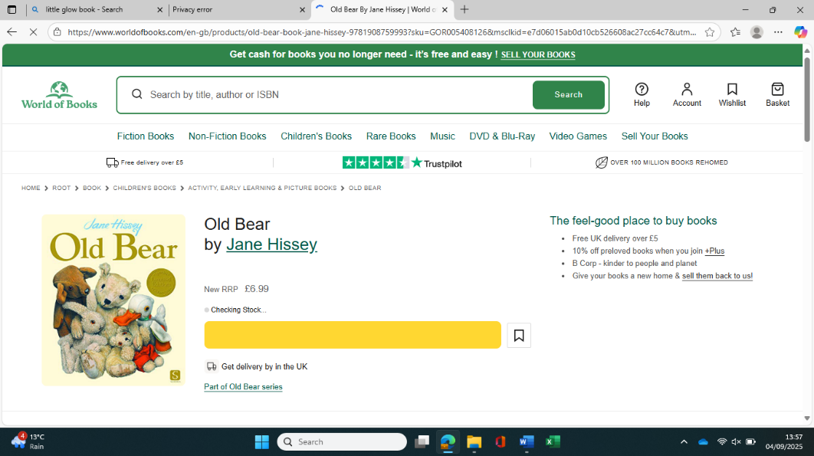  Old Bear | 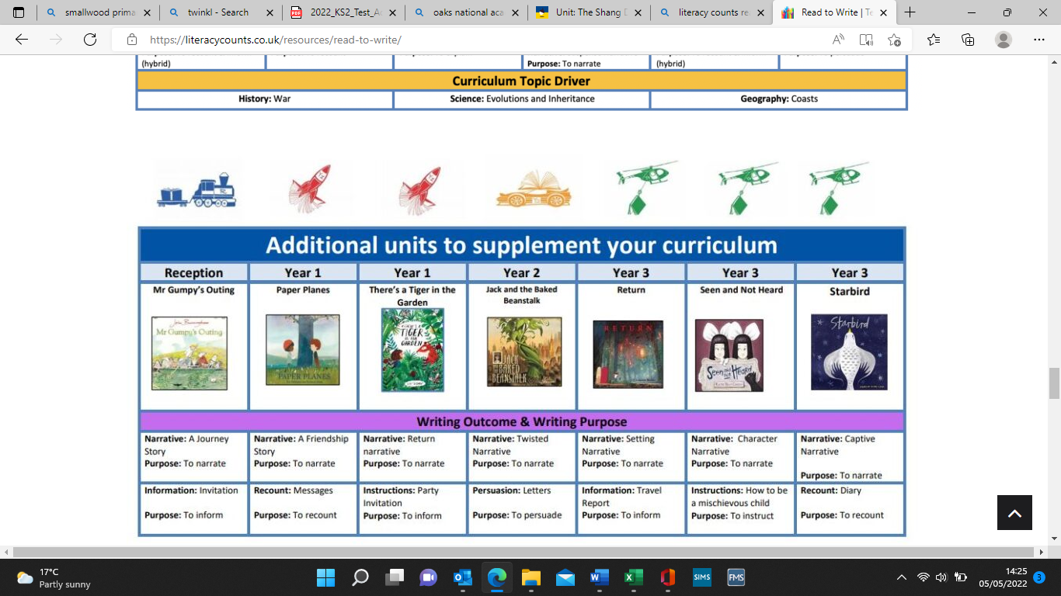  There’s a Tiger in the garden | A River  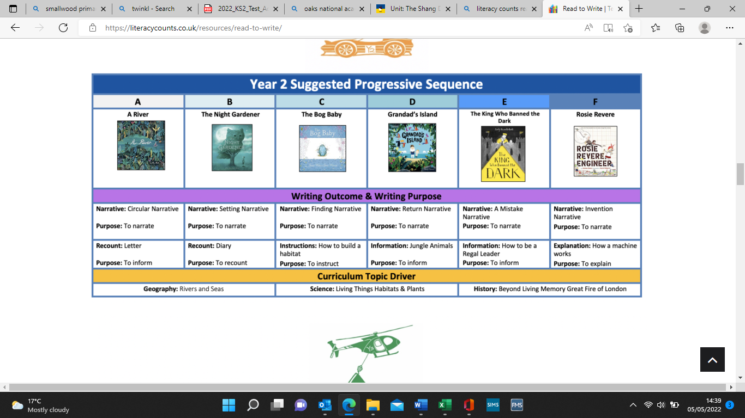 | The King who banned the dark  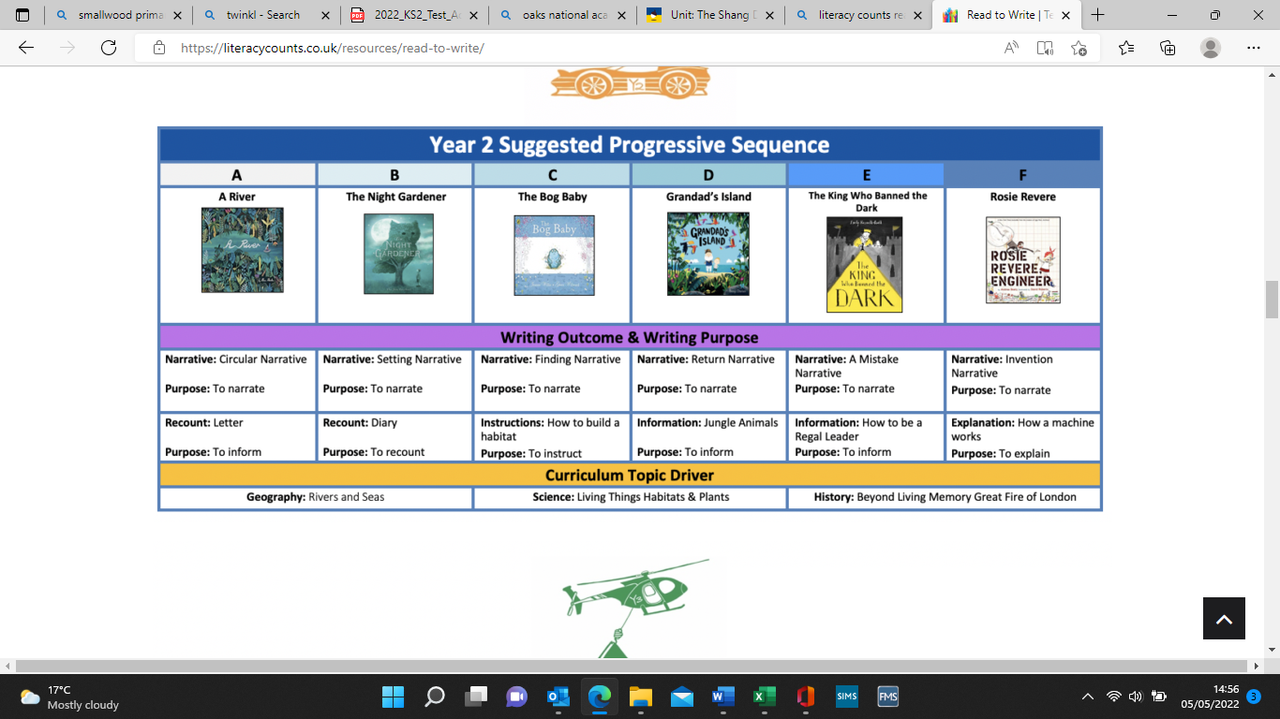
Maths | Number  Match & sort  Compare amounts  Measure, space & spatial thinking  Compare size, mass & capacity  Exploring pattern |  | Place Value | Addition and Subtraction | Place Value | Addition & Subtraction
Science | Understanding the world  Animals including humans | Understanding the world  Seasonal Changes (energy) | Materials | Energy (seasonal change) | Using Materials | Healthy Animals
PE | Gymnastics (In the jungle) | Ball Skills | Dance (toys) | Skill acquisition/ application (movement, running & jumping) | Gymnastics (landscapes & cities) | Skill acquisition (attacking & defending)
Computing | Getting used to a computer |  | Technology All Around Us | Digital Painting | Information Technology All Around | Digital Photography
No Outsiders | To make friends with someone different. | To say what I think. | To recognise that people are different ages. | To understand that I share the world with lots of people. | To understand what diversity is. | To understand how we share the world.
Art | Expressive Art & Design  Painting  Colours  (Kandinsky)  Collage  Faces from natural materials | Expressive Art & Design  Painting/ Sculpture  (fireworks/ Diwali candles) | Drawing and Painting Skills Portraits  (Van Gogh, Paul Klee, Andy Warhol) | - | Drawing and Painting skills Landscapes  (Hundertwasser) | -
D & T | Physical development/ fine motor skills  Using scissors, play dough animals | Food Tasting from different continents | - | Cooking and nutrition: preparing, tasting and evaluating fruit and vegetables from different continents | - | Structures: designing and constructing a throne for a monarch.
RE | Christianity  Christenings/ baptism | Christianity  The Christmas Story | Cross Religious  -God as creator, in Christianity, Judaism and Islam  -Shabbat  -Harvest Festival | Christianity/ other  -Incarnation/ Nativity  -Character analysis  -Christmas church celebrations | Christianity/ other  -Bible stories  -Stories from another religion | Christianity  -Jesus as King  -Why does Christmas matter to Christians?
PSHE/ SRE | Getting to know school  *Road Safety* | Good friend  *Fire Safety* | Getting to know you/ Class Rules  * Road Safety* | Tales that teach us  *Fire Safety* | Celebrating Diversity  * Road Safety* | Tales that teach us  *Fire Safety*
Music | -Listening & responding to rhymes and songs  -Explore and engage in music making/ dance | -Listening & responding to rhymes and songs  -Explore and engage in music making/ dance | -Singing a variety of songs  -Pitch (high/low)  -Pulse (exploring sounds) | -Performing chants  -Playing repeated patterns  -Using symbols to represent sounds | -Performance (creating rhythms)  -Stick notation to reflect pitch/ dynamics | -Simple structure of sounds  -Creating rhythms using simple word phrases  -Understanding how sounds depict different moods  -Dot notation
French | -Simple greetings and name  -Numbers 0-10  -Animals/ pets | -Colours  -Basic body parts  -Christmas vocabulary | -Greetings  -Numbers 0-20  -Revision of colours  -Toys | -Numbers 0-20  -Colours for fruit  -Revision of body parts  -Christmas vocabulary | -Numbers 0-30  -Colours (describing more than 1 colour)  -What do we see in a town? | -Age, months of the year & birthdays  -Christmas vocabulary
Forest School | -Collect twigs and sticks to write name  - Use natural materials to make the numbers to 20.  -Clay hedgehogs  -Leaf rubbing/ printing | -Firework art with natural resources  -Fire: fire safety & toasting marshmallows | -Mud face sculptures  -Leaves, nature self-portrait  -Learn to carry sticks safely/ story telling with sticks  -Fire: fire safety & toasting marshmallows  Outdoor Adventurous Activities | -‘Big Art’ to make the seven continents/animals from different continents  -‘Big Art’ to make landmarks from different continents  -Welly walk  Outdoor Adventurous Activities | -Welly walk to local farm  -Build a lean-to den (to include work with leaves)  -Fire & smores  Outdoor Adventurous Activities | -Drawing real natural objects such as flowers, pinecones, feathers etc. (explore using shading and pattern to add texture).  -Collect natural resources to make a crown for a monarch  Outdoor Adventurous Activities
Educational Visits/ Experiences |  | Christmas surprise/ Christmas production (New Vic Theatre) | Grandparent/ Great grandparent interviews | Visitors from different continents  Christmas production (New Vic Theatre) | Local farm visit/ environment welly walk | Christmas production (New Vic Theatre)

 | YEAR 3 |  | YEAR 4
 | AUTUMN 1 | AUTUMN 2 | AUTUMN 1 | AUTUMN 2
Topic Name | Water, weather & climate | Stone Age to Iron Age | Ancient Greece | The Arctic
Humanities | Geography- the water cycle, weather, climate and river study | History- changes in Britain from the Stone Age to the Iron age | History- a study of Greek life and their achievements/ influence on the western world | Geography- Comparing and contrasting the North Pole with deciduous woodland
English (quality text) | The Rhythm of the rain  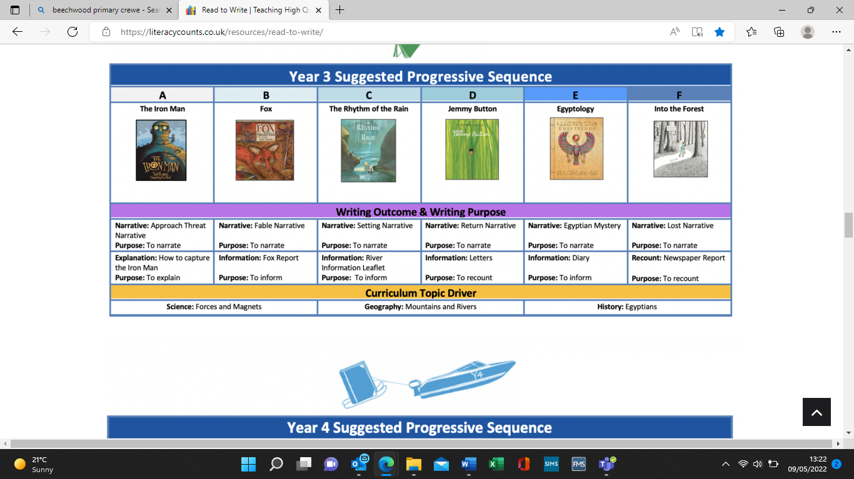 | Stone Age Boy/ How to wash a woolly mammoth  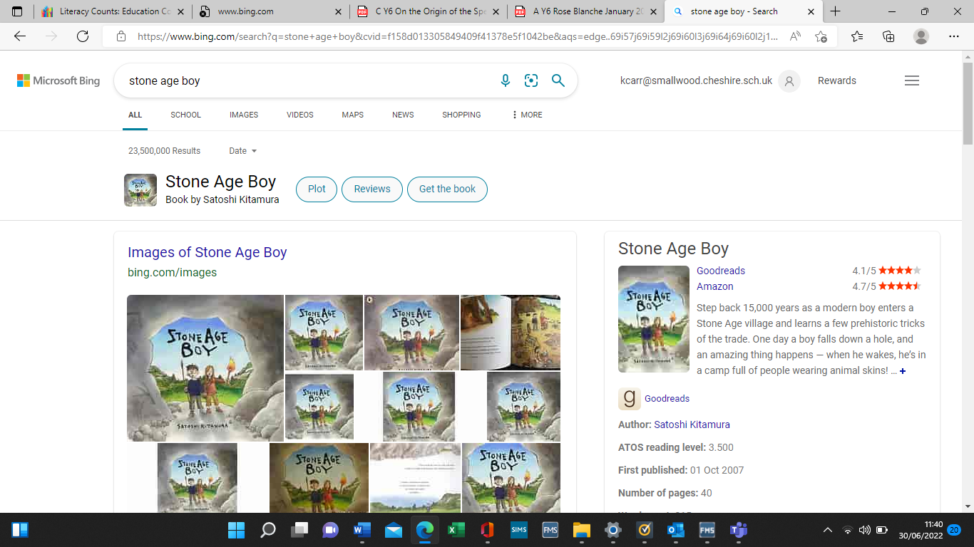 | Leo and The Gorgon’s Curse  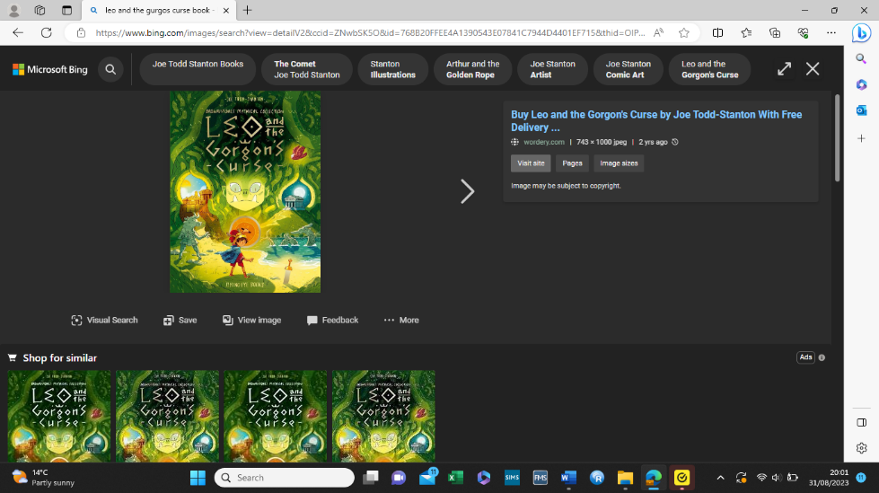 | Leaf  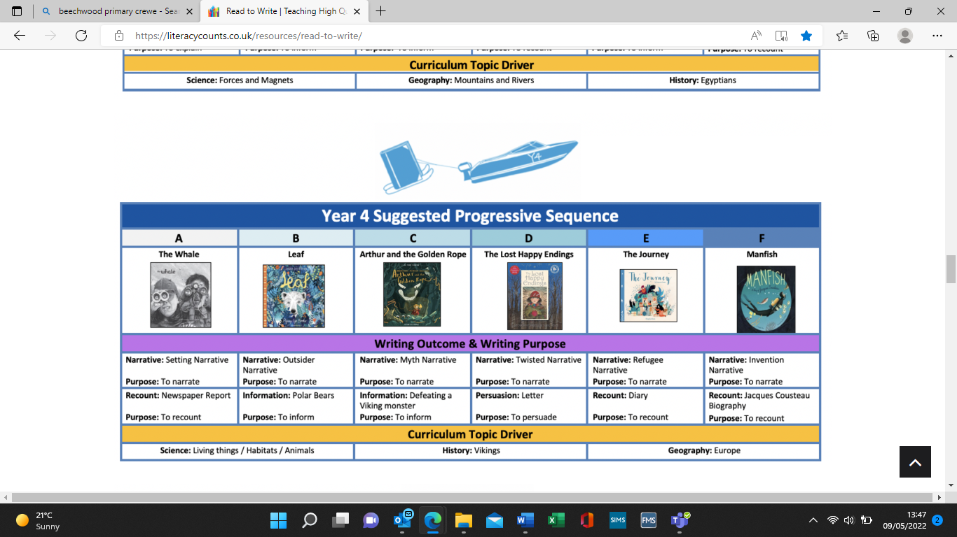
Maths | Place Value | Addition & subtraction | Place Value | Addition & subtraction
Science | Keep | Light and Shadow | Chewing, Churning and Chains (digestive system, teeth and food chains) | Freezing and Melting
PE | Invasion Games (tag rugby) | Gymnastics (shape) | Invasion Games (tag rugby)  Swimming | Gymnastics (shape & balance)  Swimming
Computing | Connecting Computers | Stop Frame Animation | The Internet | Auto Production
No Outsiders | To be proud of who I am | To understand what ‘discrimination’ means. | To understand why people choose to get married. | To overcome language as a barrier.
Art | Painting  To understand and explore how Monet used light and colour to create impressions of the River Thames.  (Claude Monet) | - | Printing  Greek pottery/ ceramics  (Clarice Cliff) | Sculptures  Land sculptures  (Andy Goldsworthy)
D & T |  | Cooking & nutrition: healthy and varied diets (compare with the Stone Age) | - | -
RE | Cross Religious  -God the creator in Christianity, Judaism and Islam  -Buddhism | Christianity  -Incarnation  -How was Jesus welcomed compared to babies today? | Christianity  -Key Bible texts  -Commandments and rules in other religions | Christianity  -Jesus as King & saviour  -Jesus as part of the Trinity  -Holy Spirit  -Concepts of God, e.g. humanism
PSHE/ SRE | Getting to know you/ setting rules  *Road Safety* | Home Life  *Fire Safety* | Ethical Reasoning  *Road Safety* | Community  *Fire Safety*
Music | -Composing music in response to different stimuli  -Rhythm grids  -Combining sounds to create different moods | -Singing songs in unison from varying styles  -Performing on tuned percussion | -Introducing singing in harmony  -Introducing rhythmic notation  -Looking at key features of different genre of music | -Introducing singing in harmony  -Introducing rhythmic notation  -Looking at key features of different genre of music  -Using rhythmic notation  -Composing simple lyrics
French | -Weather & weather maps  -Months & seasons | -Alphabet  -Numbers 0-50  -Christmas vocabulary | -Transport  -Numbers 0-60 | -Interest & hobbies  -Christmas vocabulary
Forest School | -Make a water filter  -Welly walk  -Fire: striking with a fire-steel  Outdoor Adventurous Activities | -Look at different knots, focussing on stage 1 of the overhand knot system (use to build a den)  -Make stone age style weapons using sticks, stone and rope/ Stone Age fire  -DIY charcoal paint for ‘cave painting’  Outdoor Adventurous Activities | -Assisting fire lighting  -Den building  -Greek architecture: design and create Greek style column using natural materials  Outdoor Adventurous Activities | -Welly walk  -Use natural resources to make sculptures & patterns in the style of Andy Goldsworthy  -Christmas craft using natural materials  Outdoor Adventurous Activities
Educational Visits/ Experiences | - | Stone Age workshop  Christmas production (New Vic Theatre) | - | Christmas production (New Vic Theatre)

 | YEAR 5 |  | YEAR 6
 | AUTUMN 1 | AUTUMN 2 | AUTUMN 1 | AUTUMN 2
Topic Name | Save our Planet! | Ancient Maya | Frozen Kingdom (Antarctica) | World War II
Humanities | Geography- sustainability, global warming and natural resources | History- A study of Ancient Maya | Geography- A study of Antarctica and its human and physical features (compare and contrast with the Arctic) | History- extending pupils’ knowledge beyond 1066 by looking at the causes of WW II and changes in Britain during the Blitz
English (quality text) | Greta and the Giants  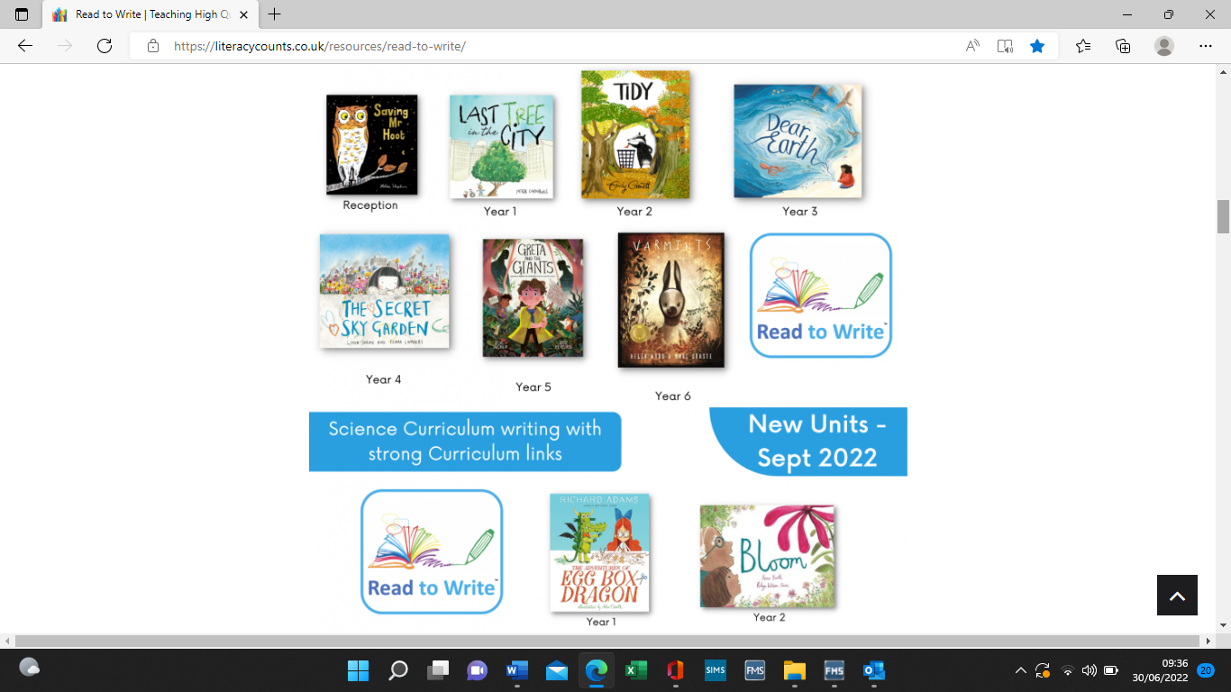 | Rain Player  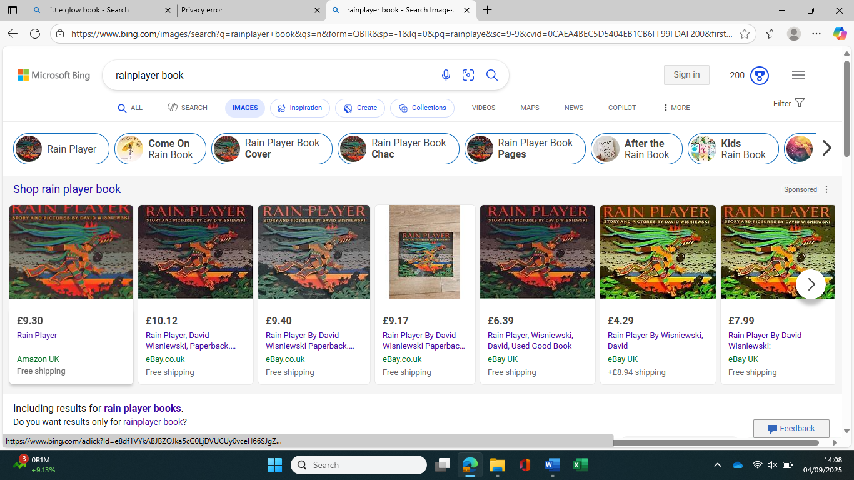 | Shackleton’s Journey  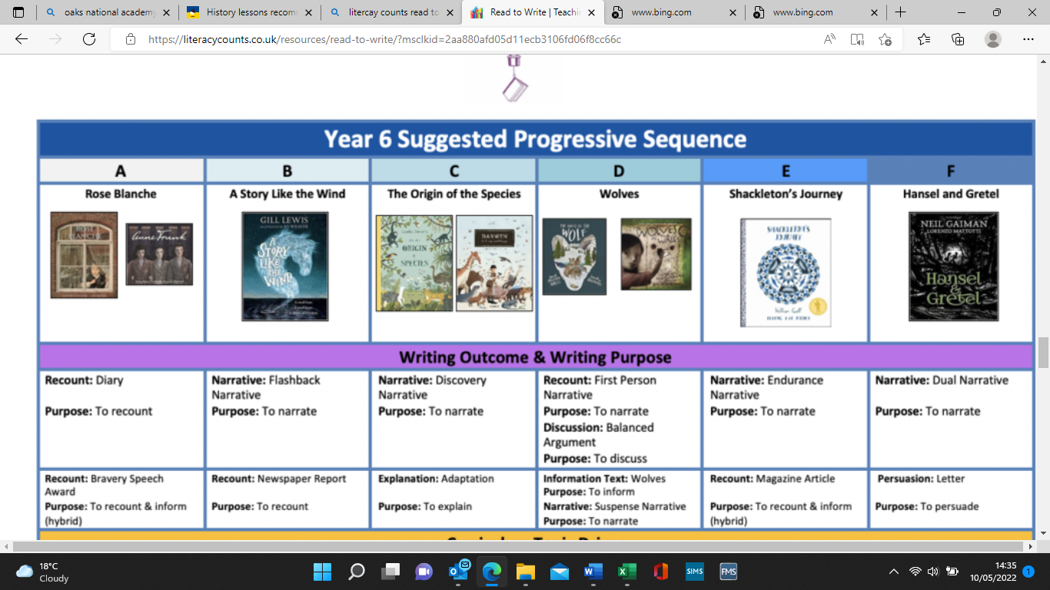 | Rose Blanche  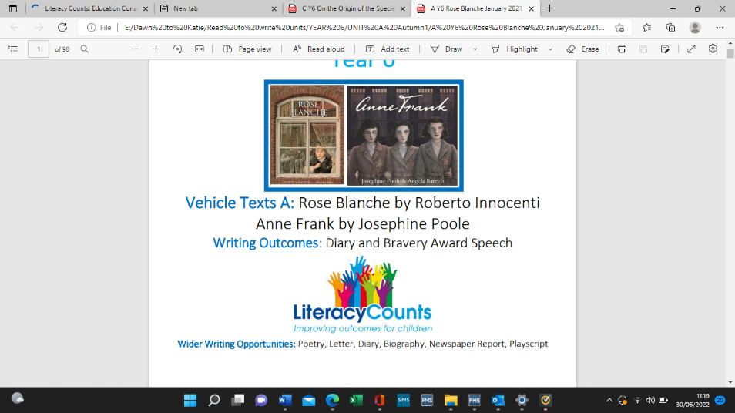
Maths | Place Value | Addition & Subtraction | Place Value  Addition & Subtraction | Addition & Subtraction  Multiplication & Division
Science | Materials and our impact on the planet | Lifecycles | Light | Electricity
PE | Dance (Eco Dance) | Invasion Games (netball) | Invasion Games (hockey) | Dance (WWII/ Through the decade)
Computing | Systems and Searching | Video Production | Communication and Collaboration | Webpage Creation
No Outsiders | To recognise when someone needs help. | To learn from our past. | To stand up to discrimination. | To justify my actions.
Art | - | Ceramics  Tiles/ Maya Temples | Painting  Antarctica landscapes  (Van Gogh/ David Rosenthal) | Printing (collagraph)  Poppies to represent war
D & T | Circuits- solar powered light
RE | Hinduism: Sanatana & Dharma  -Gods  -Symbols  -Divali  -Stories of Vishnu, Rama, Sita | Christianity/ Other  -Key texts in the Bible  -Kingdom of God  -Temptations of Jesus  -Kingdom parables | Hinduism: Sanatana & Dharma  -Recap concept of God  -Reincarnation/ karma  -Life after death  -Vegetarianism | Christianity  -God in hard times  -Peace, worship, prayer  -Old Testament prophecies (Jesus’ birth)
PSHE/ SRE | Cultural Diversity  *Road Safety* | Cultural Diversity  *Fire Safety* | Conflict  The Rule of Law  *Road Safety* | Community  *Fire Safety*
Music | -Composing melodies on tuned percussion  -Composing a short, structured piece of music  -Musical chords | -Extending rhythmic notation (naming)  -Time signatures | -Following stave notation  -Composing melodies using major and minor scales | -Composing music for a particular occasion  -Using music technology
French | -At home  -Numbers 0-80  -Vocabulary linked to sustainability | -Interest & hobbies (more complex)  -Christmas vocabulary | -Alphabet (spelling words)  -Places in a town | -Numbers 0-100  -Directions  -Christmas vocabulary
Forest School | -Go on a litter hunt around the local area.  -Reusing rubbish to make plant pots  -Assisted cooking on a fire  Outdoor Adventurous Activities | -Use natural resources to create jewellery inspired by West Africa  -Den building  Outdoor Adventurous Activities | -Making shell fossils (Link to Antarctica fossils)  -Welly Walk  Outdoor Adventurous Activities | -Build a den in the style of an Anderson shelter  -Alan Turing ‘code cracking’ treasure hunt  -Christmas craft using natural materials  Outdoor Adventurous Activities
Educational Visits/ experiences | - | Christmas production (New Vic Theatre) | Residential | Christmas production (New Vic Theatre)

